ROUTER 1
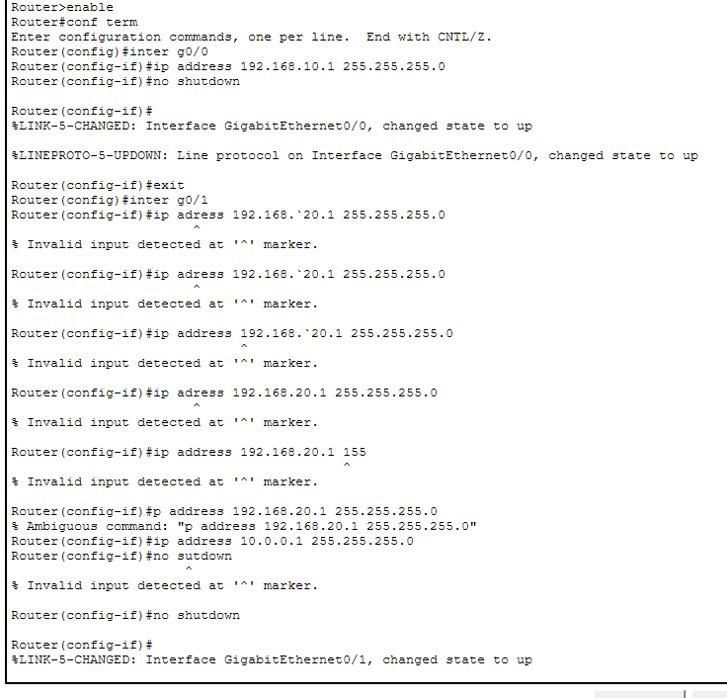
Static route
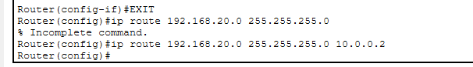
Router 2 Config
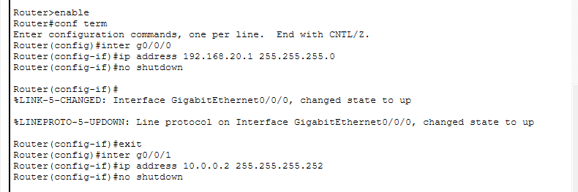
Static route
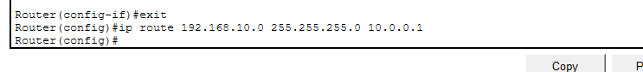
PC-A
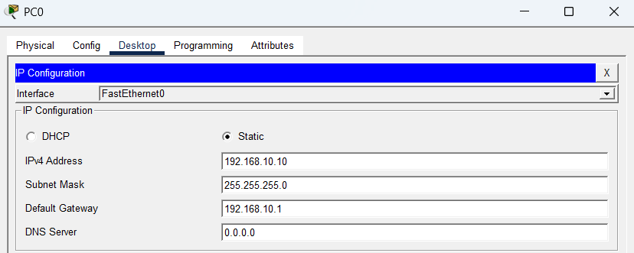
PC-B
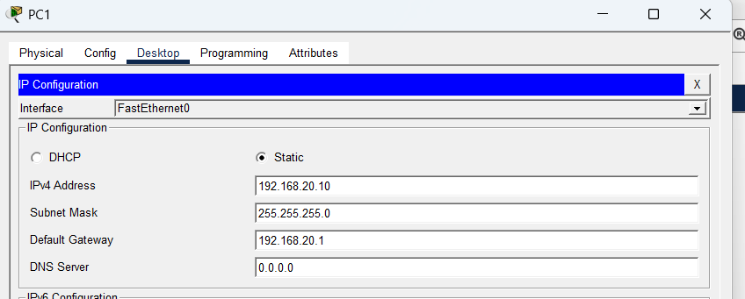
PING PC-A TO PC-B
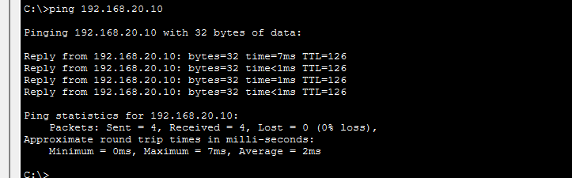
PING PC-B TO PC-A
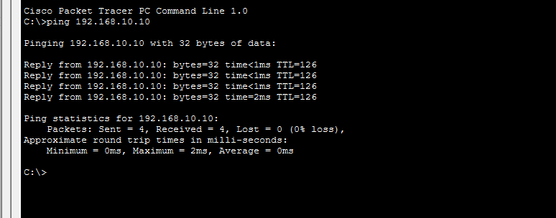
SHOW IP INTERFACE BRIEF
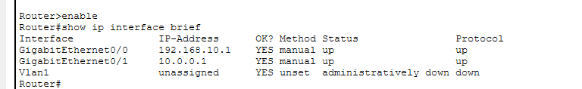
TOPOLOGY
